JAVA EXCEPTION HANDLING
What is java exception handling ?
mechanism tohandle the runtime errors.

Exception?
Abnormal condition that disrupts the normal flow. It is an object that is thrown at runtime.

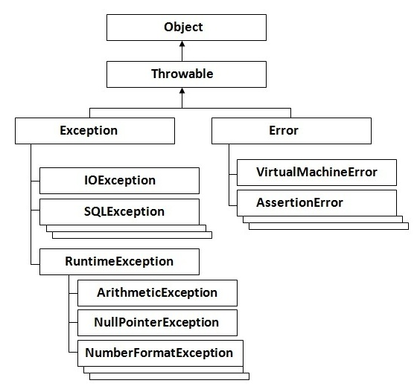

The sun microsystem says there are three types of exceptions:
- Checked Exception
- Unchecked Exception
- Error
Checked Exception
extend Throwable except RuntimeException.
Unchecked Exception
extend RuntimeException.

Error
Error is irrecoverable e.g. OutOfMemoryError, VirtualMachineError, AssertionError etc.

Try catch
Java try block is used to enclose the code that might throw an exception. It must be used within the method.
Java try block must be followed by either catch or finally block.

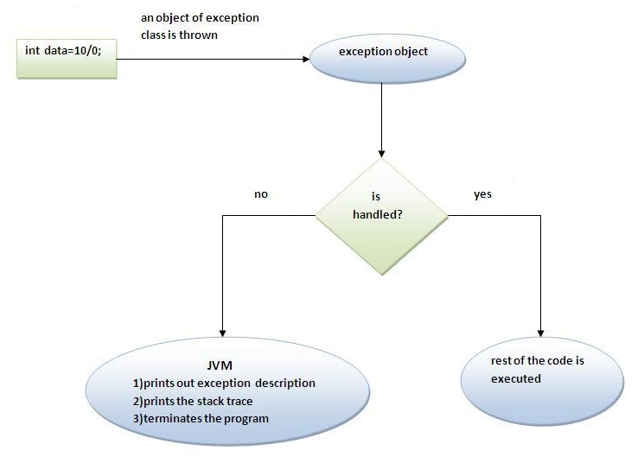

Java multi catch block
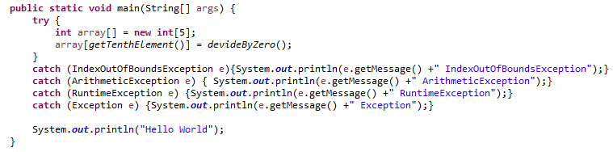
Can we use only Exception?
Yes. But when an exception is thrown. You do not know exactly this exception belong to which method.

At a time only one Exception is occured and at a time only one catch block is executed.

All catch blocks must be ordered from most specific to most general.

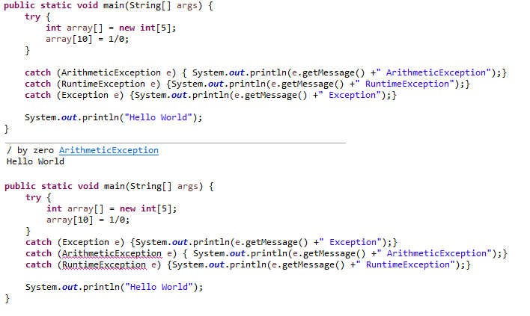
NEST TRY CATCH

JAVA FINALLY BLOCk
Java finally block is a block that is used to execute important code such as closing connection, stream etc.
Java finally block is always executed whether exception is handled or not.
Java finally block must be followed by try or catch block.

If you don't handle exception, before terminating the program, JVM executes finally block(if any).

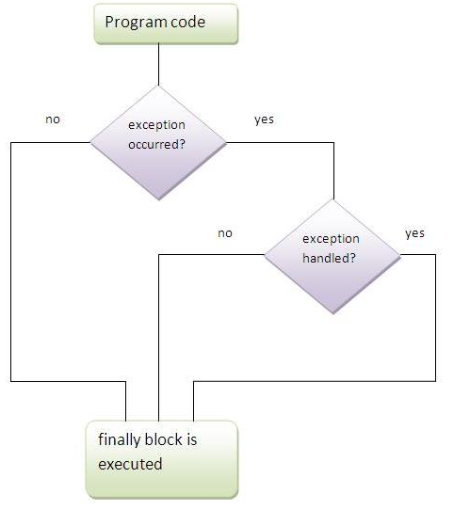
Example Finally block

No finally block the connection will wait for many method called before closing.

Must do that. It will make sure, the connection always close after run statements inside try block.
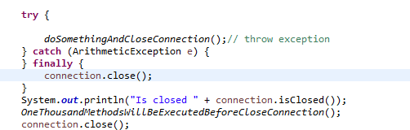

For each try block there can be zero or more catch blocks, but only one finally block.

The finally block will not be executed if program exits(either by calling System.exit() or by causing a fatal error that causes the process to abort).

Throw
The Java throw keyword is used to explicitly throw an exception.
We can throw either checked or uncheked exception in java by throw keyword. The throw keyword is mainly used to throw custom exception.

By default Unchecked Exceptions are forwarded in calling chain(propagated).
class ExceptionTest {
void m() {
int data = 1 / 0;// This is unchecked exception
}

void n() {
m();
}

void p() {
try {
n();
} catch (Exception e) {
System.out.println("Exception handled");
}
}

public static void main(String args[]) {
ExceptionTest obj = new ExceptionTest();
obj.p();
System.out.println("Hello World");
}
}

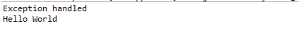

By default, Checked Exceptions are not forwarded in calling chain (propagated).
class ExceptionTest {
void m() throws FileNotFoundException {
//int data = 1 / 0;// This is unchecked exception
InputStream input = new BufferedInputStream(new FileInputStream(new File("file path")));
//This is checked EXCEPTION. Which method call this method must throw exception.
}

void n() throws FileNotFoundException {
m();
}

void p() {
try {
n();
} catch (Exception e) {
System.out.println("Exception handled");
}
}

public static void main(String args[]) {
ExceptionTest obj = new ExceptionTest();
obj.p();
System.out.println("Hello World");
}
}

THROW VS THROWS

1. Explicitly throw an exception. | Declare an exception.

2. Checked exception cannot be propagated using throw only. | Checked exception can be propagated with throws.

3. Throw is followed by an instance. | Throws is followed by class.

4. Throw is used within the method. | Throws is used with the method signature.

5. You cannot throw multiple exceptions. | You can declare multiple exceptions e.g.  public void method()throws IOException,SQLException.

OVERRIDING METHOD EXCEPTION

If the superclass method does not declare an exception, subclass overridden method cannot declare the checked exception but can declare unchecked exception.
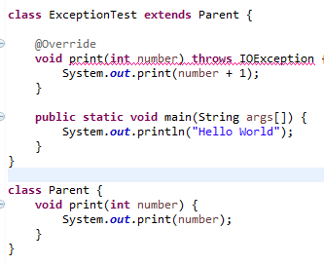

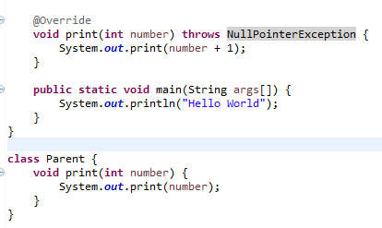
If the superclass method declares an Checked exception, subclass overridden method can only declare the same checked exception or no exception
